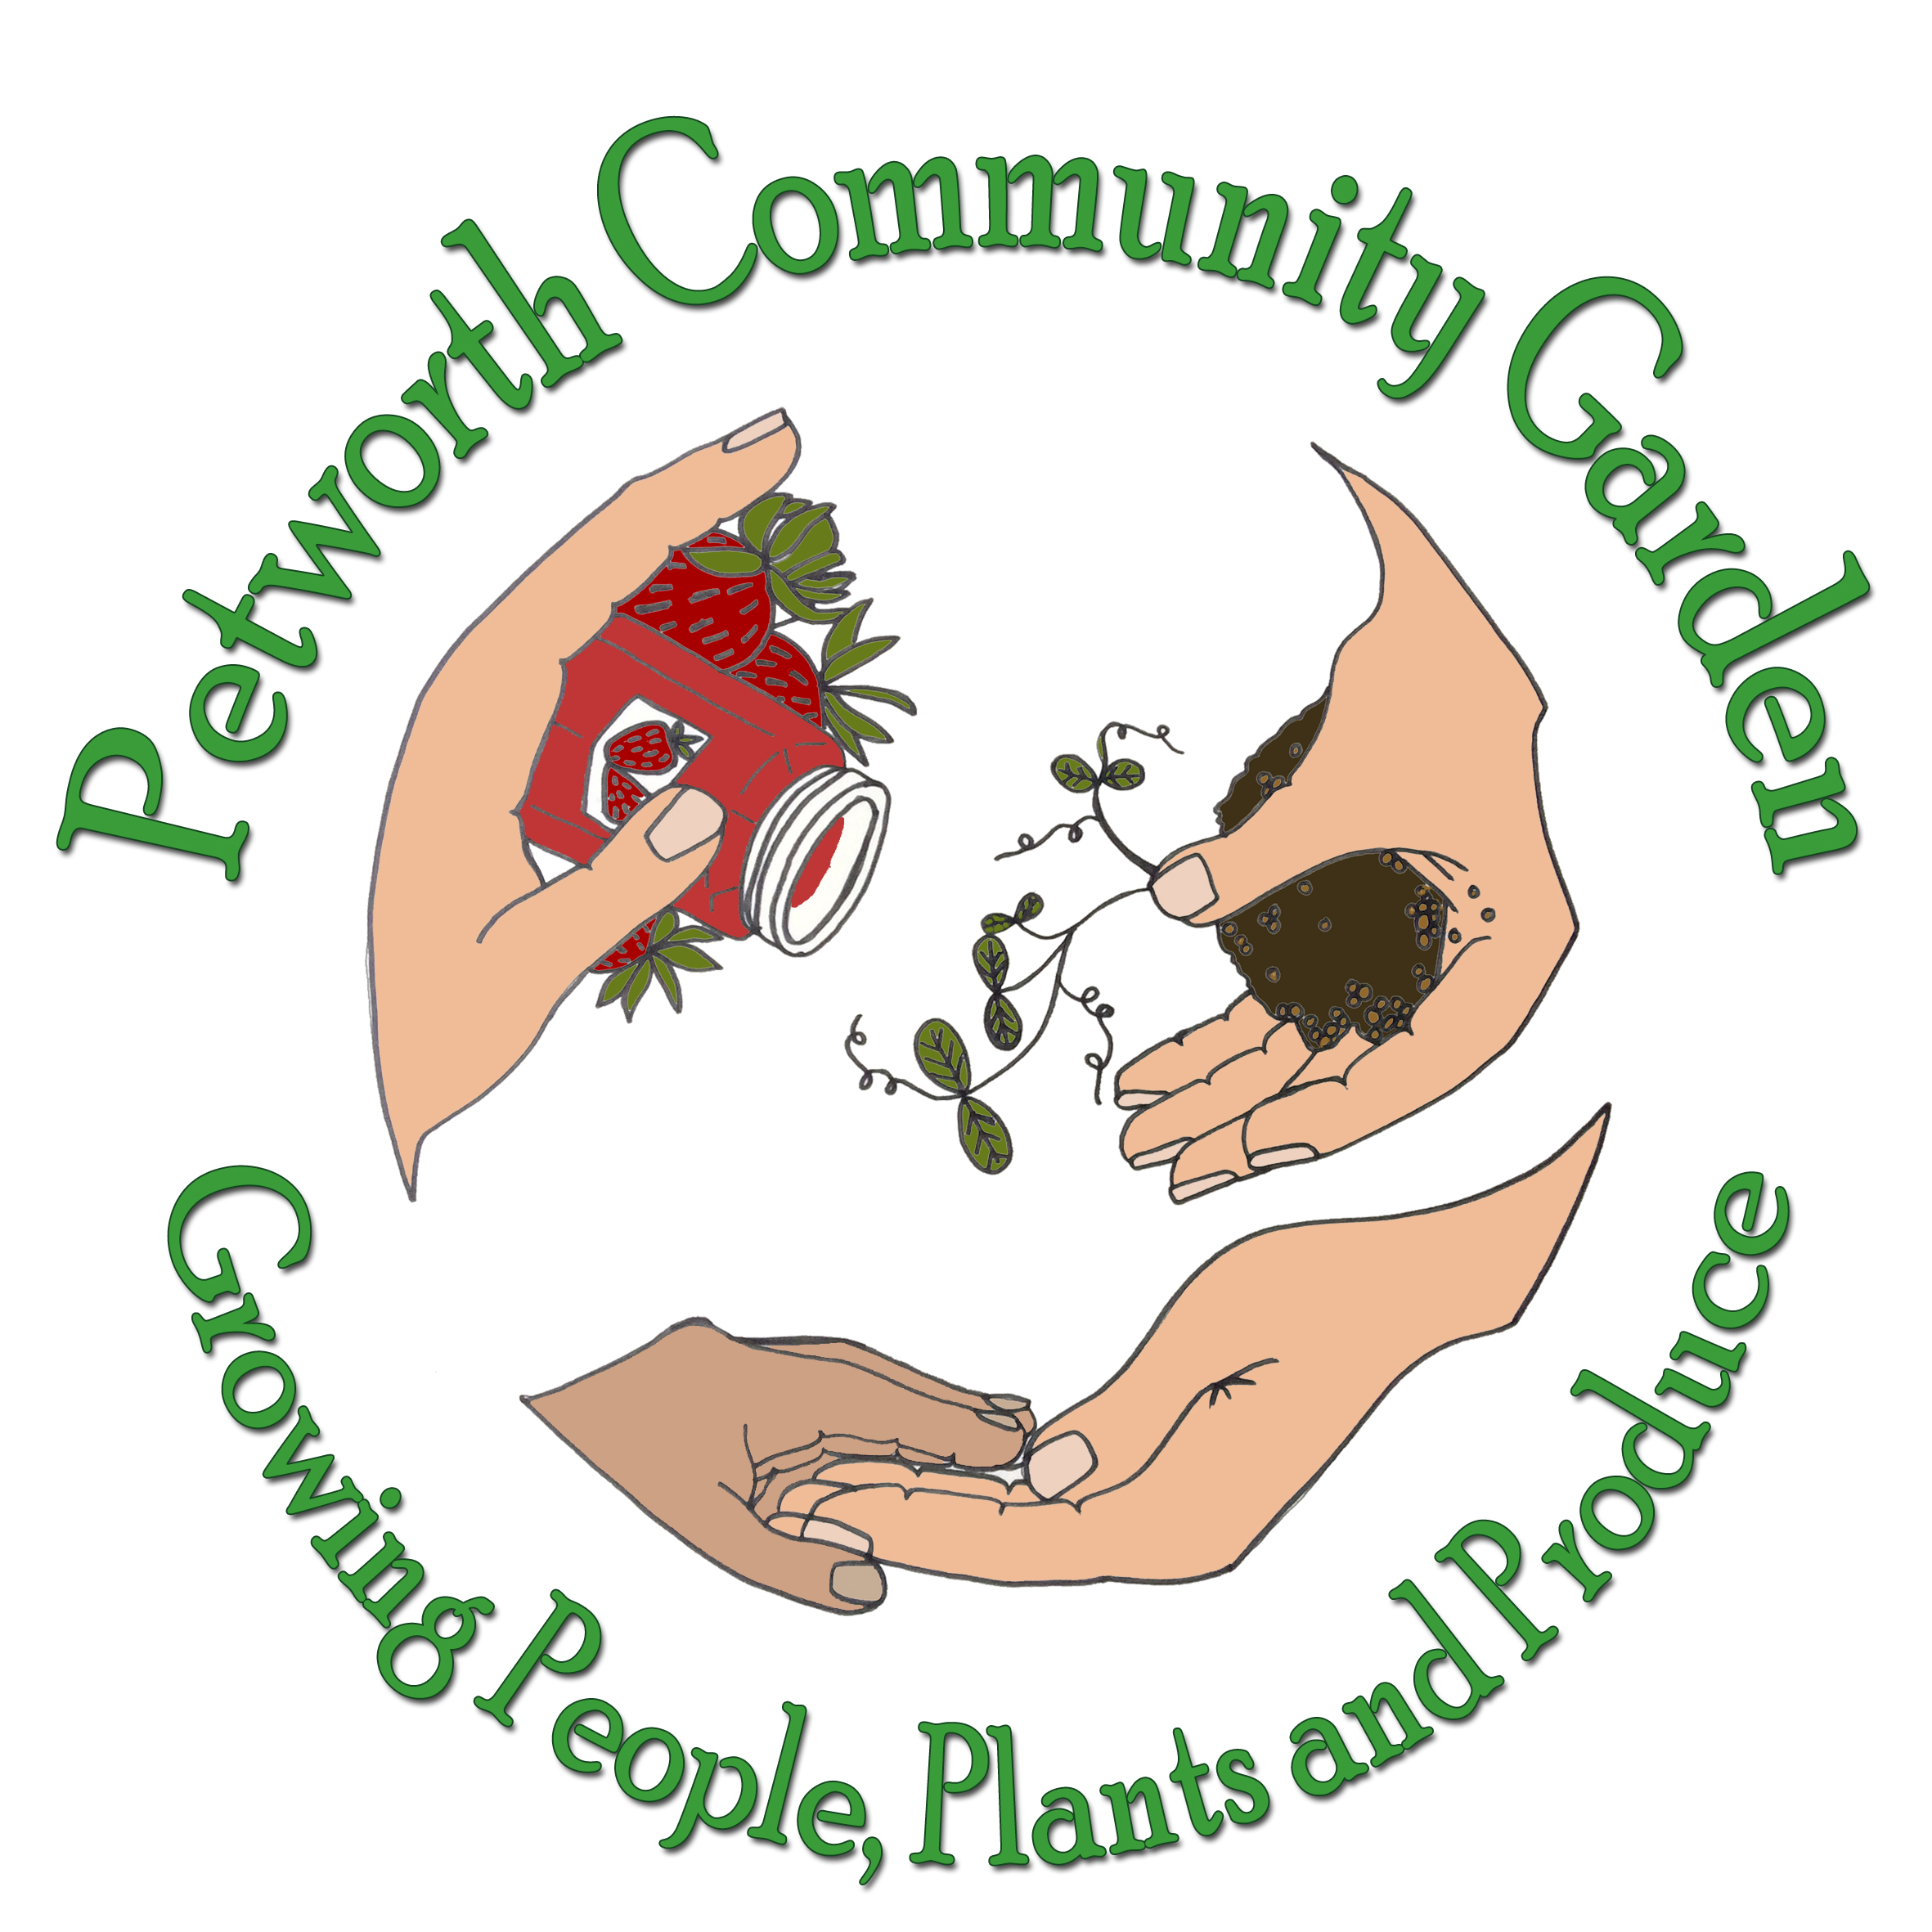Petworth Community Garden
Job Description Form
Petworth Community Garden is an equal opportunities employer.
Location: Petworth Community Garden, Meadow Way, Petworth, West Sussex, GU280EP
Job title: Social and Therapeutic Horticulture Practitioner
Reports to: The Directors: Petworth Community Garden C.I.C

Type of position: Part time, £15.00- £17.50 per hour (according to experience) salaried position. | Hours: 8- 16 hrs per week covering either 8 hours on Tuesdays, 8 hours on Thursdays or both sessions at Petworth Community Garden  From April 2021
General Description:
Petworth Community Garden is an integrated wheelchair accessible community project working with a wide range of the community including older people, children and young people, wheelchair users, people with physical or learning disabilities, and other additional needs, people with mental health challenges and other locals including those at risk of food poverty. We are looking for people who can offer skilled, caring, respectful, good humoured support, to enable all members to benefit from the therapeutic gardening, food growing and eco activities within our community garden setting. An understanding of the challenges of rural deprivation and isolation, and a passion for growing organic food and enabling wellbeing through Nature is needed. Experience or interest in Permaculture would be beneficial, as the garden and projects are designed from the permaculture ethics of People Care, Earthcare and Fair shares.

- This position is for an STH practitioner who will be running accessible horticulture sessions on site for mixed ability groups of people including those with learning disabilities or additional needs on Tuesdays. The Thursday sessions offering more bespoke STH programmes on site for people with mental health support needs.
- Duties include, planning, preparing, carrying out and monitoring sessions according to need for a variety of people within our community garden setting in order to make gardening accessible to all. Working individually and as part of a team of staff and volunteers you will be running therapeutic gardening activities for a Tuesday 'Learn and Grow' session and/or a 'Thriving Thursday' session
Successful applicants will be DBS checked to enhanced level.
Work experience needed:
Experience in planning and running STH sessions.
Professional organic gardening experience.
Health and social care or community and voluntary sector work experience.
Experience working alongside people with a wide range of health challenges and additional support and care needs, particularly those on the Autistic spectrum and people with mental health support needs.
Education and skills required

Thrive training in Social and Therapeutic Horticulture
Permaculture, Organic gardening/ RHS gardening qualifications preferred.
Mental Health or Social care qualifications.
We are particularly looking for good people skills and an ability to work responsibly both individually and as part of a team.
Reviewed by: Jennifer Yuill
Title: Director
Approved by: Richard Green
Title: Chair of Directors
Date posted: 24.03.21

