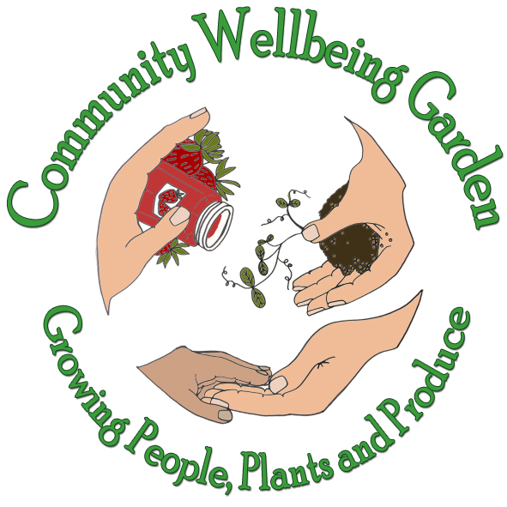
COMMUNITY
WELLBEING GARDEN CIO
Charity Number 1212007
https://communitywellbeinggarden.org/
Email application to: Rosamund@petworthcommunitygarden.co.uk
Application for Employment
Our policy is to provide equal employment opportunity to all suitable persons without regard to race, creed, color, religious belief, sex, age, national origin, ancestry, physical or mental disability, or veteran status.

Date:
Name:
Address:

Postcode:
Phone:
Email:
Please attach your CV
Are you willing to be DBS checked to enhanced level? Yes /No

- Which position are you applying for?

- How did you hear of this opening?
- Have you ever volunteered or worked in a community project or charity? Yes /No
When?
Where?
May we contact this organisation? Yes/No

- Are you presently employed? Yes /No
Where?
How long for?

- When would you be available to start?

Education : Please list your relevant qualifications and training below:
Qualifications Level Grade

- Please describe the work experience and skills you have that are relevant for this role. Relevant life experiences are also valued:

- Are you presently studying? Yes /No
If yes, where and what courses of study?

- Employment History (Start with current or most recent employer)
Company Name:
Address:
Telephone:
Email:
Position:
Responsibilities:
Date Started:
Date Ended:
Name of Supervisor/Manager:
May we contact? Yes / No
Reason for leaving:

Company Name:
Address:
Telephone:
Email:
Position:
Responsibilities:
Date Started:
Date Ended:
Name of Supervisor/Manager:
May we contact? Yes / No
Reason for leaving:

Company Name:
Address:
Telephone:
Email:
Position:
Responsibilities:
Date Started:
Date Ended:
Name of Supervisor/Manager:
May we contact? Yes / No
Reason for leaving:

References
List two personal references, not related to you, who have known you for more than three years.
Name:
Address:
Email:
Phone:
Years Known:
How do they know you?

Name:
Address:
Email:
Phone:
Years Known:
How do they know you?

Please Read Before Signing:
I certify that all information provided by me on this application is true and complete to the best of my knowledge and that I have withheld nothing that, if disclosed, would alter the integrity of this application.
I authorize my previous employers, schools, or persons listed as references to give any information regarding employment or educational record. I agree that this company and my previous employers will not be held liable in any respect if a job offer is not extended, or is withdrawn, or employment is terminated because of false statements, omissions, or answers made by myself on this application. In the event of any employment with this company, I will comply with all rules and regulations as set by the company in any communication distributed to the employees.

Signature: Date:

This information will be stored according to General Data Protection Regulation, used solely by Community Wellbeing Garden (CWG) for organisational purposes only. It will not be disclosed to any third party without your prior permission or unless required to do so by law.
I agree to CWG storing my data according to GDPR (please tick ) Yes / No

